Date 11th March 2025

Blenheim Gardens Estate

Brixton Hill
Lambeth
SW2

Dear Residents,

Ref: Wates Site Compound Set Up Notification

We have been appointed by Lambeth Council to carry out Decarbonisation Energy Improvement works within your area and on Blenheim Gardens Estate. The work will cover the period from 17th March 2025 until around April 2026.

The works are being supported by Blenheim Gardens RMO.
,
In order to carry out the proposed works, we require to set up a site compound which will include a double stacked welfare unit and storage containers in the Car Park Area of Ramillies Close. Please refer to attached/below map.

Delivery of the welfare units including set up will be on:

Tuesday 18th and Wednesday 19th March 2025

To enable the site compound to be installed we kindly ask for your vehicle situated in parking spaces as per attached map to be cleared by Monday 17th March 2025 to facilitate the foundation installation prior to the Containers arriving on Tuesday 18th March 2025.

The site compound will be at this location for the full duration of the works.

If you have any questions regarding the contents of this letter, please contact Wates Resident Liaison Officer on the details below. Our working hours are from 8.00am to 5.00pm, Monday to Friday or pop into our site office situated at 58 Prague Place, SW2 (Tuesday and Thursday 08:00am to 16:00pm).

We look forward to working together and hope to minimise any inconvenience this may cause you over this 3-day installation.

Yours faithfully,

Ernesta Sauliunaite
Resident Liaison Officer
E: Ernesta.sauliunaite@wates.co.uk
M: 07933 504 883

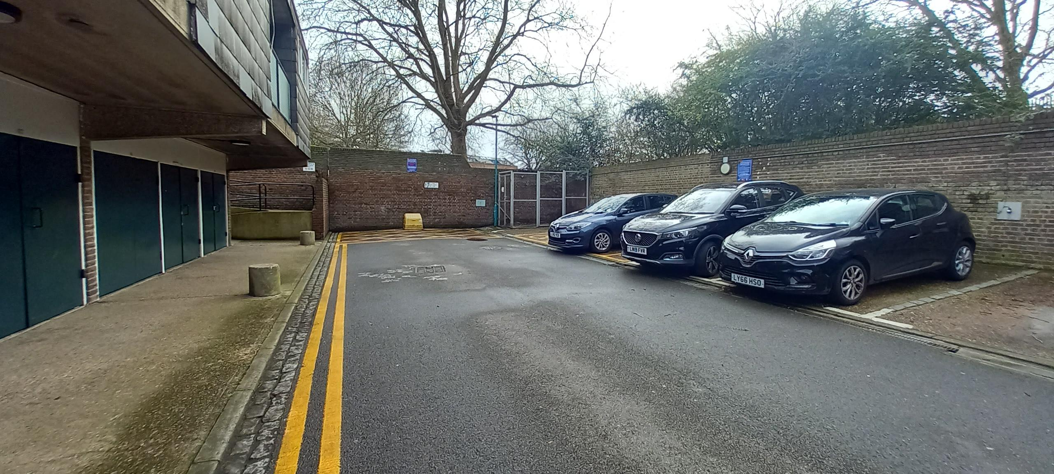
Site Cabins will be situated in the first 6 Bays after the disabled bay located next to the refuse cage area. The Site Office will be double stacked but leaving the road way clear in front, it won’t impose on sunlight and all windows will be filmed for Privacy.

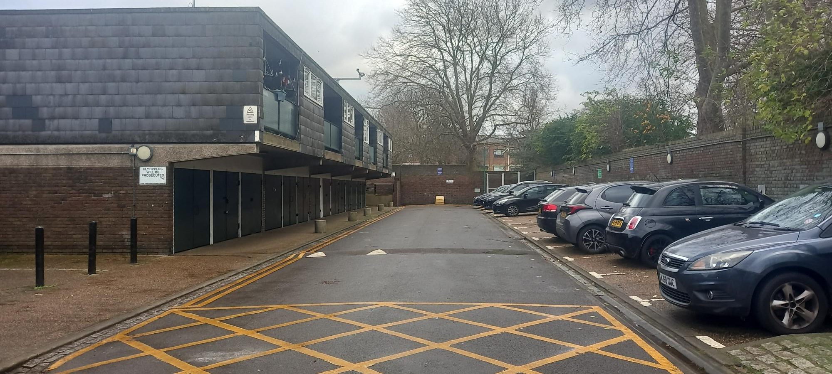
Only for the purposes of the installation and crane will the following 18nr Parking Bays be suspended from Monday 17th – Wednesday 19th March 2025 after this period it will be reduced down.

